The Role of the State on Ahnenerbe and Akademgorodok

Justin Butler

October 15th, 2020

**Introduction**

The state plays a massive role on the overall advancement of knowledge. The 1940s was one of the darkest times in human history. Nazi Germany had committed heinous crimes against humanity. Crimes that are still felt and remembered by some still alive today. The resulting war had a dramatic effect on the knowledge of the time. The need to discover and invent new technology drove nations to put forth all they could to achieve victory during World War 2. From Joseph Mengele’s experiments, Wernher von Braun’s rocketry advancements, Turing’s machine that laid groundwork for modern computers. All the way to the Manhattan Project. Every field saw massive advancement out of necessity. With all this advancement also saw large brain drains as the Holocaust saw many leading experts removed. Post world war 2, Stalin’s paranoia saw those executed.

One entity within the Nazi regime was called Ahnenerbe. This think tank was set up to `study` the Nazi ideologies. On the other side during the post Stalin era, the Soviet Union set up an entity called Akademgorodok in the town of Novosibirsk. These two think tanks were created and funded under two fundamentally different states. During each of their times, both were great institutions as viewed by the people within them. Both saw their prime and great successes in the eyes of those within them but as we will discuss, only one of them was truly in pursuit of knowledge while the other was at the will of the state.

**Nazi Germany**

In 1933 Adolf Hitler came to power which begun the Third Reich also known as Nazi Germany. The Nazi ideology in which they thought of the Germanic people as descendants of an Aryan race. This led to anti-Semitism policies slowly being added throughout the 1930s. It started off as Jews being barred from government positions. Then to being stripped of citizenship. As it got worse by the year, eventually their property was confiscated and were herded into ghettos. These policies were progressively more severe as time went on.

Many Jews that could fled from Germany during this time but was extremely difficult in the latter years. One notable person who fled was Albert Einstein. Unfortunately, many other brilliant minds were not so lucky. In 1941 The Final Solution was put into action which saw nearly two thirds of the European Jewish population exterminated.

**Ahnenerbe**

The Ahnenerbe, the think tank dedicated to researching the radical Nazi ideologies was founded in 1935 by Heinrich Himmler. The main objective was to research evidence of the accomplishments of the Germanic ancestors. Essentially this was to find evidence for their Aryan supremacy. This was all propaganda though, they were distorting the truth and releasing tailored evidence that gives credit to Hitler.

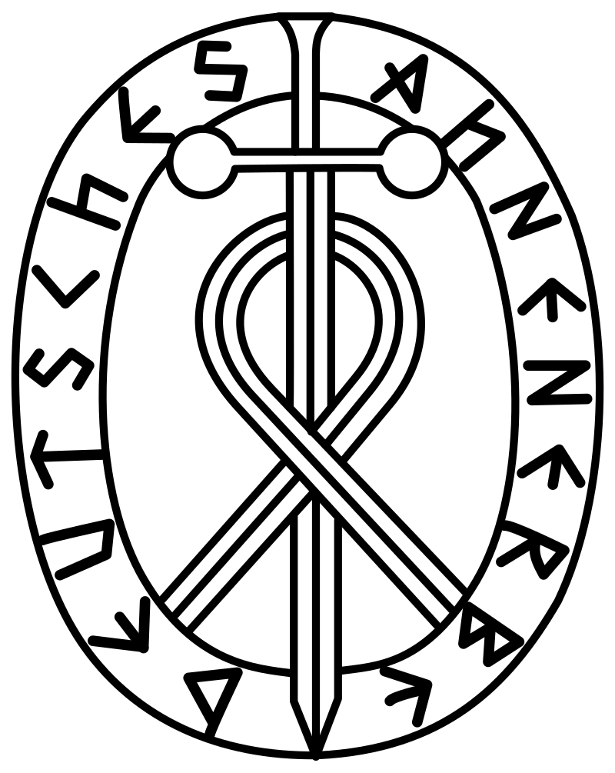

(*Ahnenerbe Emblem*, n.d.)

Initially this institute was researching ancient texts, engravings, and folklore. In February 1938 Himmler transferred the SS Excavations Department into Ahnenerbe. This seems like a propaganda stunt to show that joining the SS would allow one to become a researcher in Germanic History. Eighteen excavations were sponsored and conducted during the Ahnenerbe lifetime. The results of these expeditions and research was used by Himmler to justify the Holocaust.

During world war 2, the Ahnenerbe was responsible for the theft of many historical object, paintings, and other priceless items from museums that were thought to be of German origin. One such occurrence is from museums in Warsaw after the invasion of Poland.

**Soviet Union**

The Soviet Union was founded after the Russian revolution also known as the October Revolution led by Vladimir Lenin. This saw the country change to a socialist country. This country was led by Lenin until his untimely death in 1924.

Joseph Stalin came to power after Lenin’s death due to Stalin being appointed the Secretary. That position allowed him to appoint people to other positions, which allowed him to appoint friends and people that would aid him. This solidified his rise to power.

After world war 2, Stalin’s paranoia had gotten to him as he had his friends, family, and others deemed untrustworthy executed. This had gotten so bad to the point that top scientists and leading experts in fields were either sent to a gulag or executed. In 1953 Stalin suffered a stroke but no one got to him due to fear of bothering him in his office. Furthermore, any doctor that could do anything was either removed prior or too scared to try and help. After his death Nikita Khrushchev came to power. One of the first things he did was condemn Stalin and issued De-Stalinization reforms.

**Akademgorodok**

The Akademgorodok, is a think tank established 1957 under the Academy of Sciences of the USSR. Akademgorodok translates to Academic Town. The first institute created in the newly formed Akademgorodok was a branch of the Academy of Sciences of the USSR.

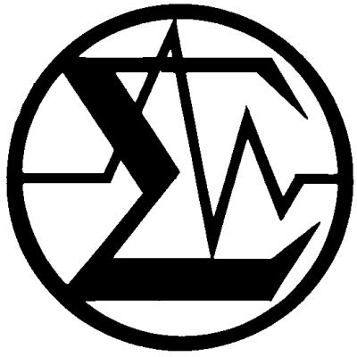

As such this town came to be filled with many institutes over time and today is currently Russia’s version of Silicon Valley.

During the early years, this town enjoyed many freedoms that were not allowed elsewhere in the union. They could study subjects that were considered pseudoscience in Moscow. This changed during the Brezhnev era as these freedoms were removed and focus was subject to economic and military needs.

(*SB RAS Emblem*, n.d.)

**Akademgorodok and Ahnenerbe**

Both think tanks were founded and funded by their states. The Ahnenerbe focused specifically on historical research while the Akademgorodok focused on all sorts of fields. They have some similarities such as state influence but also have many differences such as economic security, goals, and social ideologies.

A major difference in Akademgorodok and Ahnenerbe was the economic security of the researchers. Since the Soviet Union is a socialist nation, compensation did not directly translate to one’s standard of living. This completely contrasts the researchers in the Ahnenerbe. In Nazi Germany, the private sector was alive and well and monetary compensation was given to those in the Ahnenerbe which directly influenced one’s standard of living. Residents of Akademgorodok had a special compensation system which would increase the standard of living. For example, residents had access to special food rations not easily obtainable elsewhere. Residents also had access to single family homes which were considered luxury to the average standard of living in the Soviet Union. Russian Doctorate equivalent holders were given special access to a food delivery system which some refused as they found it morally wrong.

The Ahnenerbe was controlled by Himmler and was a branch of the SS. They embarked on numerous expeditions but was dictated by the SS and thus the state. Only if there was a case that the expedition could provide evidence of Germanic history would an expedition be approved. Other factor that affected this institute was the invasion of Poland and subsequent starting of the war saw some expeditions cancelled indefinitely.

The Ahnenerbe seemed to have destroyed much more history than created. Their expeditions provided valuable historical artifacts but the state purposely misinterpreted findings to further their agenda. As well as the theft of countless artifacts from other countries many of which are still lost to this day. This shows that the institute while stating that it is a progressive and reputable institute was just a Nazi organization set on further their own agenda while disregarding any significant historical findings. The Akademgorodok was created and operated in the exact opposite manner in the beginning. Researchers could study what they want, and the state had no interference in the research.

The Akademgorodok was affected and influence heavily by the state in the Brezhnev era. Freedoms they once had such as what research they did, and special compensation was subverted by the state. Once a place free of Moscow’s control was now under the agenda of the state.

A huge effect the state had which affected both Akademgorodok and Ahnenerbe was not the state itself but the lack of the state. Ahnenerbe was dismantled once Nazi Germany fell and Akademgorodok suffered a massive brain drain once the Soviet Union dissolved as many fled to the west. While Akademgorodok still existed post-Soviet era, it existed as a shell of what it once was until private investment was poured into the town. Then in 2005, Putin expressed interest in developing Akademgorodok, thus returning and surpassing its former glory.

**Conclusion**

In conclusion, we can see how both the Ahnenerbe and Akademgorodok were heavily influenced by the state. Both were investing in research but like their political ideologies, they had completely different agendas. Ahnenerbe was fabricating and twisting the truth while Akademgorodok was for genuine research. Both were affected by their states dissolving but Akademgorodok survived as it was a town with people still living there along with infrastructure still standing. We also see how the state can not only influence advancements but also caused massive brain drains in the form of the Holocaust and in the form of Immigration to the west.

**References**

ADL (n.d.). Nazi Germany and Anti-Jewish Policy. Retrieved October 13, 2020, from <https://www.adl.org/resources/backgrounders/nazi-germany-and-anti-jewish-policy>

History.com Editors. (2009, October 29). Adolf Hitler. Retrieved October 13, 2020, from <https://www.history.com/topics/world-war-ii/adolf-hitler-1>

Encyclopedia.com (n.d). The "Final Solution". Retrieved October 13, 2020, from <https://encyclopedia.ushmm.org/content/en/article/the-final-solution>

Pringle, H. (2006). Hitler's Willing Archaeologists. Retrieved October 13, 2020, from <https://archive.archaeology.org/0603/abstracts/nazis.html>

Pringle, H. A. (2006). *The master plan: Himmler's scholars and the Holocaust*. New York, NY: Hyperion.

Editors, H. (2017, September 01). Soviet Union. Retrieved October 14, 2020, from <https://www.history.com/topics/russia/history-of-the-soviet-union>

Wainwright, O. (2016, January 05). Step into Silicon Forest, Putin's secret weapon in the global tech race. Retrieved October 14, 2020, from <https://www.theguardian.com/artanddesign/2016/jan/05/silicon-forest-putin-secret-weapon-global-tech-race-siberia-russia>

The President held a meeting at Akademgorodok in Novosibirsk on creating technology parks in the sphere of information technology. (2005, January 11). Retrieved October 15, 2020, from <http://en.kremlin.ru/events/president/news/32576>

*Ahnenerbe Emblem*. (n.d.). [Illustration]. <https://en.wikipedia.org/wiki/Ahnenerbe#/media/File:Ahnenerbe.svg>

*SB RAS Emblem*. (n.d.). [Illustration]. <https://en.wikipedia.org/wiki/Siberian_Branch_of_the_Russian_Academy_of_Sciences#/media/File:Sigma_symbol_of_Akademgorodok.jpg>